
Book Your Shows API Documentation
Base URL: http://localhost:8080/api
Authentication
All protected endpoints require a Bearer token in the Authorization header:
Authorization: Bearer <access_token>
Token Expiry
Authentication & Users
User Registration
POST /auth/register
Create a new user account.
Request Body:
json
Access Token: 1 hour
{
"email": "name@example.com",
"mobile_number": "1234567890",
"password": "******",
"user_role": "CUSTOMER",
"first_name": "first_name",
"last_name": "second_name",
"date_of_birth": "1998-05-10",
"profile_picture_url": "https://example.com/profile.jpg",
"address_line1": "Street 1",
"address_line2": "Near Temple",
"city": "Madurai",
"state": "Tamil Nadu",

Response:
json
User Login
POST /auth/login
Authenticate user and receive access tokens.
Request Body:
json
Response:
json
Refresh Token
text
"country": "India",
"pincode": "625001"
}
{
"message": "User registered successfully",
"user_id": 1
}
{
"email": "name@example.com",
"password": "*********"
}
{ "token": "eyJhbGciOiJIUzI1NiIs.eyJhbGciOiJIUzI1NiIs............"}`


Parameter
Type
Description
user_id
integer
User identifier
POST /auth/refresh
Authorization : Bearer < token >
Refresh access token using refresh token.
Response:
json
Logout
POST /auth/logout
Authorization : Bearer < token >
Invalidate user session and tokens.
Get User Profile
text
GET /users/{user_id}
Authorization : Bearer < token >
Path Parameters:
Response:
{ "token": "eyJhbGciOiJIUzI1NiIs.eyJhbGciOiJIUzI1NiIs............"}`
{
"user_id": 1,
"first_name": "Naveen",
"last_name": "kumar",
"mobile_number": "9876343210",
"email": "nkv@gmail.com",
"date_of_birth": "1998-05-10",


Update User Profile
text
PUT /users/{user_id}
Authorization : Bearer < token >
Request Body:
Response:
Get User Address
GET /users/{user_id}/address
Authorization : Bearer < token >
Response:
"profile_picture_url": "https://example.com/profile.jpg",
"address_line1": "Street 1",
"address_line2": "Near Temple",
"city": "Madurai",
"state": "Tamil Nadu",
"country": "India",
"pincode": "625001"
}
{
"first_name": "naveen",
"last_name": "Kumar",
"date_of_birth": 1088793000000,
"address_line1": "10/30, Nehru Street, Thiruparankundram",
"city": "Dindigul",
"state": "Tamil Nadu",
"country": "India",
"pincode": "625005"
}
{ "message": "User profile updated successfully" }`


Update User Address
PUT /users/{user_id}/address
Authorization : Bearer < token >
Request:
Response:
Delete User
DELETE /users/{user_id}
Authorization : Bearer < token >
Response:
{
"address_line1": "10/30, Nehru Street, Thiruparankundram",
"city": "Dindigul",
"state": "Tamil Nadu",
"country": "India",
"pincode": "625005"
}
{
"address_line1": "10/30, Nehru Street, Thiruparankundram",
"city": "Dindigul",
"state": "Tamil Nadu",
"country": "India",
"pincode": "625005"
}
{ "message": "User address updated successfully" }`
{ "message": "User deleted successfully" }

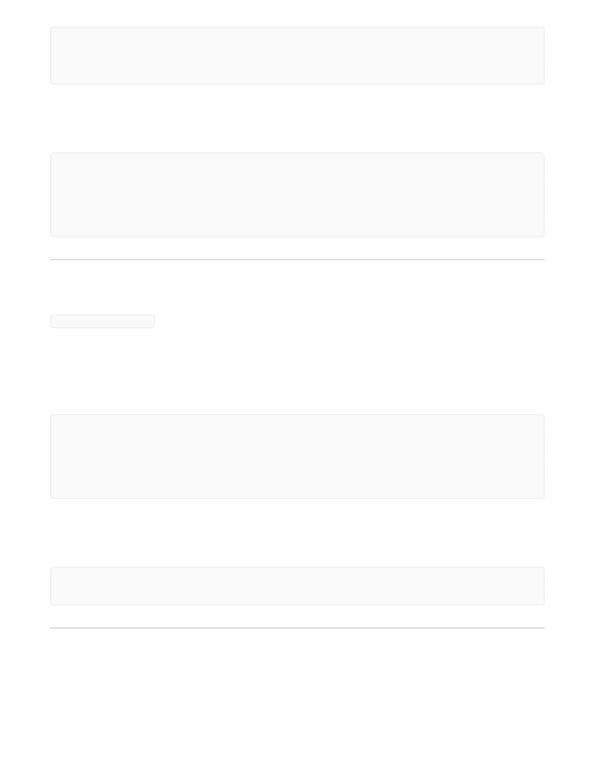

Parameter
Type
Description
role
string
Filter by user role
status
string
Filter by account status
limit
integer
Pagination limit
Get User Bookings
GET /users/{user_id}/bookings
Authorization : Bearer < token >
Response:
List All Users (Admin)
GET /users
Authorization : Bearer < token >
Query Parameters:
[
{
"booking_id": 20,
"user_id": 12,
"show_id": 6,
"total_amount": 384.0,
"booking_status": "PENDING",
"payment_status": "PENDING",
"booked_at": "2026-03-30T12:06:28.000+00:00"
},
{
"booking_id": 21,
"user_id": 12,
"show_id": 5,
"total_amount": 384.0,
"booking_status": "CONFIRMED",
"payment_status": "PENDING",
"booked_at": "2026-03-30T12:06:28.000+00:00"
}
]


Parameter
Type
Description
offset
integer
Pagination offset
Response:
json
[
{
"user_id": 1,
"first_name": "Ram",
"last_name": "Kumar",
"email": "ram@example.com",
"user_role": "CUSTOMER",
"account_status": "ACTIVE"
},
{
"user_id": 2,
"first_name": "Selva",
"last_name": "Kumar",
"email": "selva@example.com",
"user_role": "THEATRE_OWNER",
"account_status": "ACTIVE"
},
{
"user_id": 3,
"first_name": "Karthik",
"last_name": "K",
"email": "karthik@examplecom",
"user_role": "CUSTOMER",
"account_status": "ACTIVE"
},
{
"user_id": 5,
"first_name": "Madhankumar",
"last_name": "S",
"email": "madhan@example.com",
"user_role": "CUSTOMER",
"account_status": "ACTIVE"
}
]

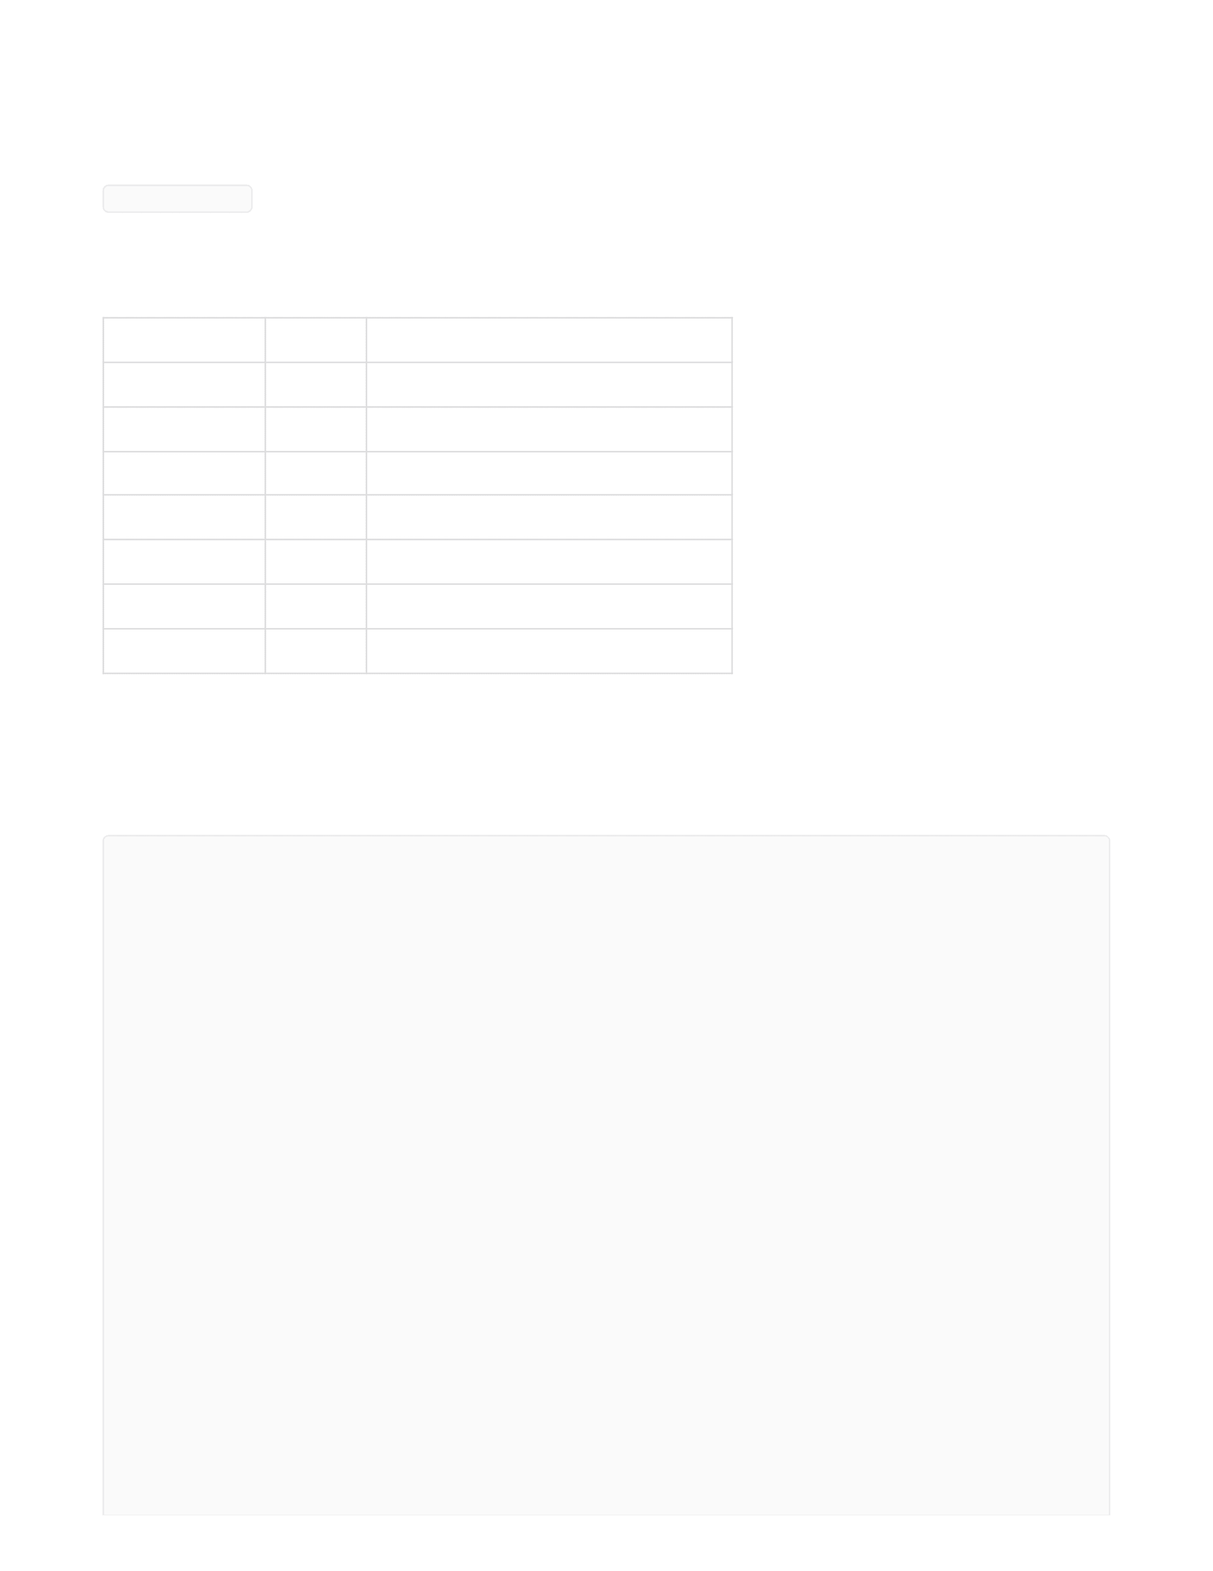
Parameter
Type
Description
limit
integer
Pagination limit (default: 10)
offset
integer
Pagination offset
name
string
Filter by movie title
language
string
Filter by language
genre
string
Filter by genre
release_year
integer
Filter by release year
sort
string
Sort field (release_date, rating)
Movies
List Movies
GET /movies
Query Parameters:
Response:
json
[
{
"movie_id": 1,
"title": "Thaai Kizhavi",
"release_date": "2026-02-27"
},
{
"movie_id": 2,
"title": "Vadam",
"release_date": "2026-02-28"
},
{
"movie_id": 3,
"title": "Dhurendher",
"release_date": "2023-10-19"
},
{
"movie_id": 6,
"title": "Sharva Maya",
"release_date": "2023-10-19"
},


Get Movie Details
GET /movies/{movie_id}
Response:
json
Create Movie (Admin)
POST /movies
Authorization : Bearer < token >
Request Body:
{
"movie_id": 7,
"title": "Inception",
"release_date": "2010-07-16"
},
{
"movie_id": 8,
"title": "The Dark Knight",
"release_date": "2008-07-18"
}
]
{
"movie_id": 6,
"title": "Sharva Maya",
"language": "Tamil",
"genre": "RomCom.",
"duration": 175,
"release_date": "2023-10-19",
"poster_url": "https://example.com/new.jpg",
"trailer_url": "https://youtube.com/new",
"description": "Updated description",
"censor_rating": "U/A"
}


Response:
json
Update Movie (Admin)
PUT /movies/{movie_id}
Authorization : Bearer < token >
Request
Response:
{
"title": "Sharva Maya",
"language": "Tamil",
"genre": "RomCom",
"duration": "160",
"release_date": "2023-10-19",
"poster_url": "https://example.com/poster.jpg",
"trailer_url": "https://youtube.com/trailer",
"description": "Action thriller movie",
"censor_rating": "U/A"
}
{
"message": "Movie created successfully",
"movie_id": 10
}
{
"language": "Tamil",
"genre": "RomCom",
"duration": "160",
"release_date": "2023-10-19",
"poster_url": "https://example.com/poster.jpg",
"trailer_url": "https://youtube.com/trailer",
"description": "Action thriller movie",
"censor_rating": "U/A"
}

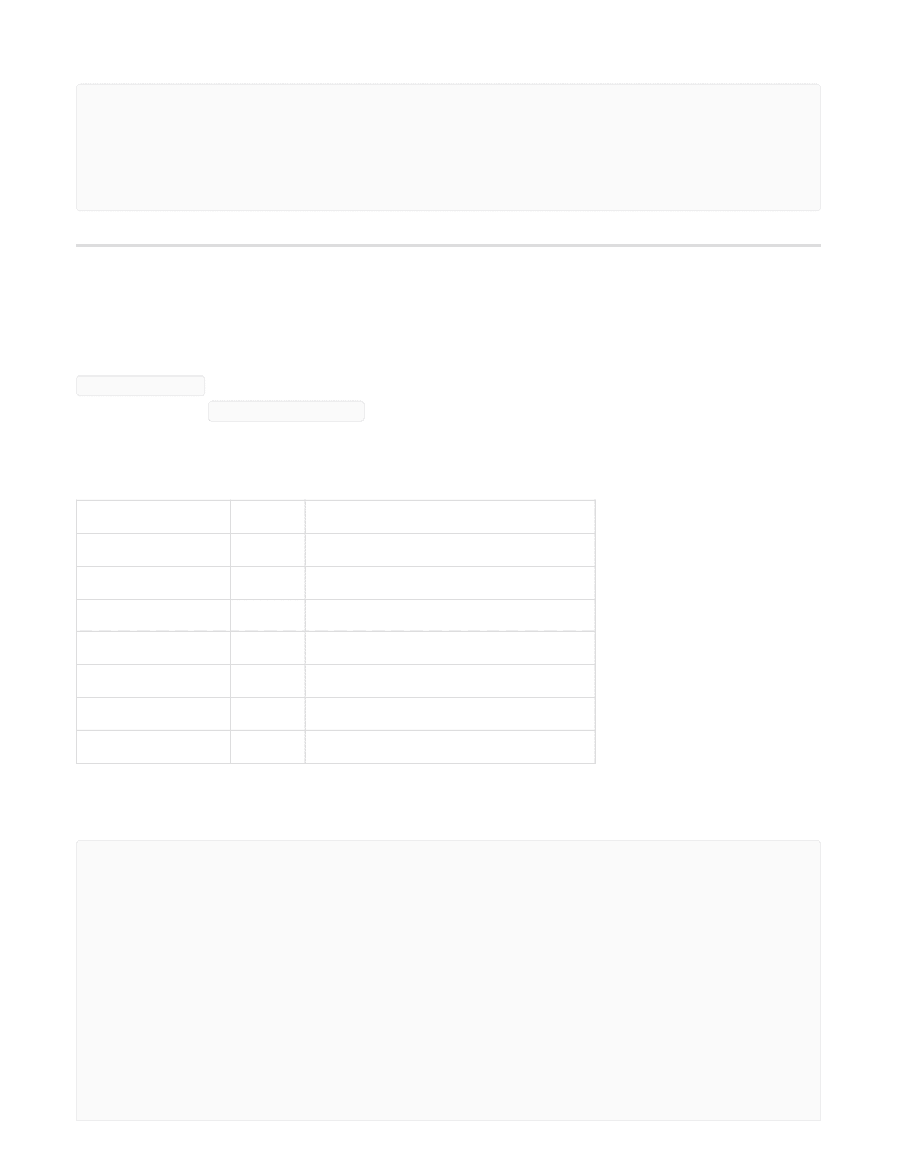
Parameter
Type
Description
limit
integer
Pagination limit
offset
integer
Pagination offset
name
string
Filter by theatre name
location
string
Filter by city
movie_id
integer
Filter by movies currently showing
status
string
Filter by approval status
registration_year
integer
Filter by registration year
json
Theatres
List Theatres
GET /theatres
Authorization : Bearer < token >
Query Parameters:
Response:
{
"message": "Movie created successfully",
"movie_id": 10
}
[
{
"theatre_id": 1,
"theatre_name": "SVR Visuals",
"total_screens": 1,
"city": "Dharapuram"
},
{
"theatre_id": 2,
"theatre_name": "Vetri Cinemas..",
"total_screens": 3,

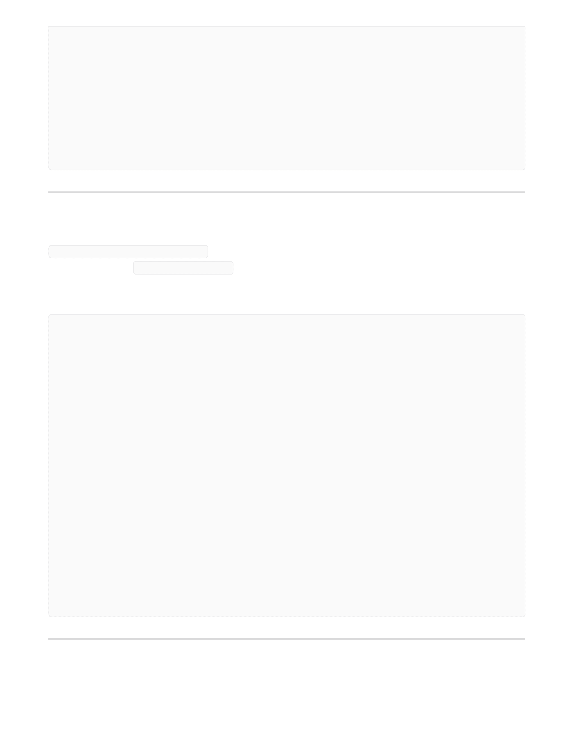
Get Theatre Details
GET /theatres/{theatre_id}
Authorization : Bearer < token >
Response:
Get Theatre Address
"city": "Dharapuram"
},
{
"theatre_id": 3,
"theatre_name": "PVR Cinemas",
"total_screens": 1,
"city": "Tiruppur"
}
]
{
"theatre": {
"theatre_id": 1,
"owner_id": 2,
"theatre_name": "SVR Visuals",
"email": "support@svr.com",
"contact_number": "9655584334",
"total_screens": 1,
},
"address": {
"address_id": 1,
"address_line1": "Near Subramaniya Swamy Temple",
"city": "Dharapuram",
"state": "Tamil Nadu",
"pincode": "625005",
"latitude": 9.8807,
"longitude": 78.0702
}
}


GET /theatres/{theatre_id}/address
Authorization : Bearer < token >
Response
Create Theatre
POST /theatres
Authorization : Bearer < token >
Request
Response:
{
"address_line1": "Some Street..",
"address_line2": "Near Main Road",
"city": "Tiruppur",
"state": "APPROVED",
"country": "India",
"pincode": "641601",
"latitude": 11.10850000,
"longitude": 77.34110000
}
{
"theatre_name": "Rohini Cinemas.",
"email": "support@rohini.com",
"contact_number": "9843414605",
"total_screens": 1,
"license_document": "https://bookyourtickets.com/lsfjgnd3vu4rie4589r9",
"address_line1": "Some Street",
"address_line2": "Near Main Road",
"city": "Tiruppur",
"state": "Tamil Nadu",
"country": "India",
"pincode": "641601",
"latitude": 11.1085,
"longitude": 77.3411
}


Update Theatre
PUT /theatres/{theatre_id}
Authorization : Bearer < token >
Request :
Response
Update Theatre Address
{
"message": "Theatre created successfully",
"theatre_id": 6,
"status": "PENDING"
}
{
"theatre_name": "Vetri Cinemas..",
"email": "support@vetriscreens.com",
"contact_number": "9999999999",
"total_screens": 3,
"license_document": "https://bookyourtickets.com/mdscreens-renewed",
"address_line1": "West Veli Street, Near Periyar Bus Stand",
"address_line2": "2nd Floor, New Wing",
"city": "Dharapuram",
"state": "Tamil Nadu",
"country": "India",
"pincode": "625001",
"latitude": 9.9252,
"longitude": 78.1198
}
{
"message", "Theatre updated successfully, Pending for admin approval"
}


PUT /theatres/{theatre_id}/address
Authorization : Bearer < token >
Response
Get Theatre Bookings (Owner and Admin)
GET /theatres/{theatre_id}/bookings
Authorization : Bearer < token >
Response:
{
"address_line1": "Some Street..",
"address_line2": "Near Main Road",
"city": "Tiruppur",
"state": "Tamil Nadu",
"country": "India",
"pincode": "641601",
"latitude": 11.10850000,
"longitude": 77.34110000
}
{
"message", "Theatre address updated successfully."
}
[
{
"booking_id": 20,
"user_id": 12,
"show_id": 6,
"total_amount": 384.0,
"booking_status": "PENDING",
"payment_status": "PENDING",
"booked_at": "2026-03-30T12:06:28.000+00:00"
},
{
"booking_id": 18,
"user_id": 1,


List Screens in Theatre
GET /theatres/{theatre_id}/screens
Authorization : Bearer < token >
Response:
"show_id": 6,
"total_amount": 384.0,
"booking_status": "CONFIRMED",
"payment_status": "SUCCESS",
"booked_at": "2026-03-30T05:11:32.000+00:00"
},
{
"booking_id": 14,
"user_id": 1,
"show_id": 6,
"total_amount": 510.0,
"booking_status": "PENDING",
"payment_status": "PENDING",
"booked_at": "2026-03-27T11:16:51.000+00:00"
}
]
[
{
"screen_id": 2,
"screen_name": "VETRI S1",
"theatre_id": 2,
"screen_type_id": 2,
"price_multiplier": 1.6,
"total_rows": 3,
"no_of_seats": 13,
"screen_type_name": "Dolby Cinema"
},
{
"screen_id": 4,
"screen_name": "MD Screen II",
"theatre_id": 2,
"screen_type_id": 1,
"price_multiplier": 1.5,
"total_rows": 4,
"no_of_seats": 20,


Get Screen Details
GET /theatres/{theatre_id}/screens/{screen_id}
Authorization : Bearer < token >
Response:
Create Screen
POST /theatres/{theatre_id}/screens
Authorization : Bearer < token >
Request Body:
Response:
"screen_type_name": "IMAX"
}
]
{
"screen_id": 1,
"screen_name": "S1",
"theatre_id": 1,
"screen_type_id": 2,
"price_multiplier": 1.6,
"total_rows": 4,
"no_of_seats": 15,
"screen_type_name": "Dolby Cinema"
}
{
"screen_name": "Rohini S3",
"screen_type_id": 1,
"total_rows": 4,
"no_of_seats": 20
}


Update Screen
PUT /theatres/{theatre_id}/screens/{screen_id}
Authorization : Bearer < token >
Response :
List Seats for Screen
GET /theatres/{theatre_id}/screens/{screen_id}/seats
Authorization : Bearer < token >
Response:
{
"message": "Screen created successfully",
"screen_id": 5
}
{
"screen_name": "Rohini s1",
"screen_type_id": 2,
"total_rows": 4,
"no_of_seats": 15
}
[
{
"row_no": 1,
"seats": [
{
"seat_id": 1,
"seat_number": "A1",
"screen_id": 1,
"seat_category": "Standard",
"price_multiplier": 1.2,
"status": "AVAILABLE"
},
{


Create Seats for Screen
POST /theatres/{theatre_id}/screens/{screen_id}/seats
Authorization : Bearer < token >
Request Body:
"seat_id": 2,
"seat_number": "A2",
"screen_id": 1,
"seat_category": "Standard",
"price_multiplier": 1.2,
"status": "AVAILABLE"
}
]
},
{
"row_no": 2,
"seats": [
{
"seat_id": 6,
"seat_number": "B1",
"screen_id": 1,
"seat_category": "Standard",
"price_multiplier": 1.2,
"status": "AVAILABLE"
},
{
"seat_id": 7,
"seat_number": "B2",
"screen_id": 1,
"seat_category": "Standard",
"price_multiplier": 1.2,
"status": "AVAILABLE"
}
]
}
]
[
{
"row_no": 1,


Response:
"segments": [
{
"seat_category_id": 1,
"seat_count": 5
}
]
},
{
"row_no": 2,
"segments": [
{
"seat_category_id": 1,
"seat_count": 2
},
{
"seat_category_id": 2,
"seat_count": 3
}
]
},
{
"row_no": 3,
"segments": [
{
"seat_category_id": 3,
"seat_count": 5
}
]
},
{
"row_no": 4,
"segments": [
{
"seat_category_id": 4,
"seat_count": 5
}
]
}
]
{
"message": "Seats created successfully",

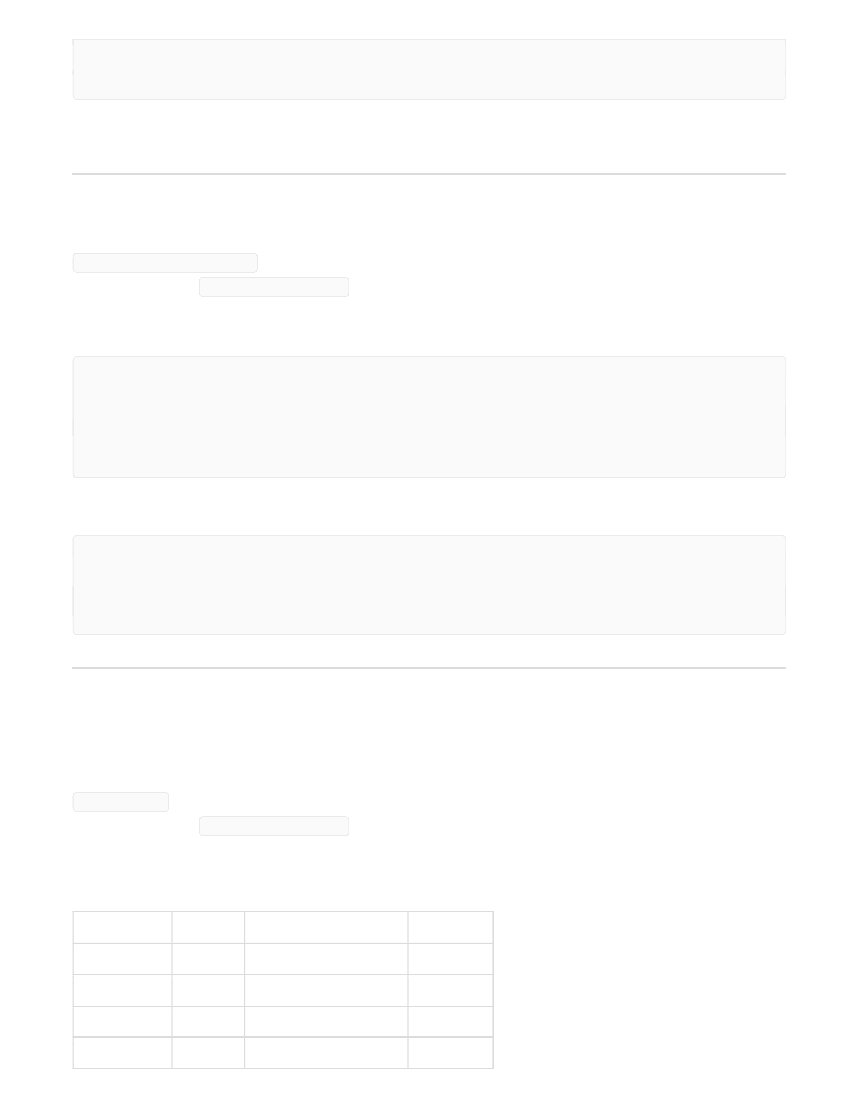
Parameter
Type
Description
theatre_id
integer
Filter by theatre
Optional
movie_id
integer
Filter by movie
Required
date
string
Filter by show date
Required
location
String
Filter by city
Required
`
Update Seat
PUT /seats/{seat_id}
Authorization : Bearer < token >
Request Body:
Response:
Shows
List Shows
GET /shows
Authorization : Bearer < token >
Query Parameters:
"total_seats_created": 10
}
{
"seat_category_id" : 2,
"status" : "MAINTENANCE"
}
{
"message": "Seats created successfully"
}


Response:
[
{
"theatre_id": 2,
"shows": [
{
"show_id": 30,
"theatre_id": 2,
"theatre_name": "Vetri Cinemas..",
"theatre_location": "Dharapuram",
"screen_id": 2,
"screen_name": "VETRI S1",
"movie_id": 2,
"show_date": "2026-08-03",
"start_time": "20:00:00",
"end_time": "00:00:00",
"base_price": 100.0,
"status": "SCHEDULED"
},
{
"show_id": 34,
"theatre_id": 2,
"theatre_name": "Vetri Cinemas..",
"theatre_location": "Dharapuram",
"screen_id": 2,
"screen_name": "VETRI S1",
"movie_id": 2,
"show_date": "2026-08-03",
"start_time": "20:00:00",
"end_time": "00:00:00",
"base_price": 100.0,
"status": "SCHEDULED"
}
]
},
{
"theatre_id": 1,
"shows": [
{
"show_id": 30,
"theatre_id": 1
"theatre_name": "Vetri Cinemas..",
"theatre_location": "Dharapuram",
"screen_id": 2,


Get Show Details
GET /shows/{show_id}
Authorization : Bearer < token >
Response:
"screen_name": "VETRI S1",
"movie_id": 2,
"show_date": "2026-08-03",
"start_time": "20:00:00",
"end_time": "00:00:00",
"base_price": 100.0,
"status": "SCHEDULED"
},
{
"show_id": 34,
"theatre_id": 1,
"theatre_name": "Vetri Cinemas..",
"theatre_location": "Dharapuram",
"screen_id": 2,
"screen_name": "VETRI S1",
"movie_id": 2,
"show_date": "2026-08-03",
"start_time": "20:00:00",
"end_time": "00:00:00",
"base_price": 100.0,
"status": "SCHEDULED"
}
]
}
]
{
"show_id": 1,
"theatre_id": 1,
"theatre_name": "",
"theatre_location": "",
"screen_id": 1,
"movie_id": 1,
"show_date": "2026-03-27",
"start_time": "09:00:00",
"end_time": "12:00:00",


Get Seat Availability for Show
GET /shows/{show_id}/seats
Authorization : Bearer < token >
Response:
"base_price": 100.0,
"status": "COMPLETED"
}
[
{
"row_no": 1,
"seats": [
{
"show_seat_id": 126,
"row_no": 1,
"seat_id": 0,
"seat_number": "A2",
"category": "Standard",
"status": "BOOKED",
"final_price": 192.0
},
{
"show_seat_id": 125,
"row_no": 1,
"seat_id": 0,
"seat_number": "A1",
"category": "Standard",
"status": "BOOKED",
"final_price": 192.0
},
{
"show_seat_id": 128,
"row_no": 1,
"seat_id": 0,
"seat_number": "A4",
"category": "Standard",
"status": "AVAILABLE",
"final_price": 192.0
},
{


"show_seat_id": 127,
"row_no": 1,
"seat_id": 0,
"seat_number": "A3",
"category": "Standard",
"status": "AVAILABLE",
"final_price": 192.0
},
{
"show_seat_id": 129,
"row_no": 1,
"seat_id": 0,
"seat_number": "A5",
"category": "Standard",
"status": "AVAILABLE",
"final_price": 192.0
}
]
},
{
"row_no": 2,
"seats": [
{
"show_seat_id": 131,
"row_no": 2,
"seat_id": 0,
"seat_number": "B2",
"category": "Standard",
"status": "AVAILABLE",
"final_price": 192.0
},
{
"show_seat_id": 130,
"row_no": 2,
"seat_id": 0,
"seat_number": "B1",
"category": "Standard",
"status": "AVAILABLE",
"final_price": 192.0
},
{
"show_seat_id": 133,
"row_no": 2,
"seat_id": 0,
"seat_number": "B4",
"category": "Gold",


"status": "AVAILABLE",
"final_price": 208.0
},
{
"show_seat_id": 132,
"row_no": 2,
"seat_id": 0,
"seat_number": "B3",
"category": "Gold",
"status": "AVAILABLE",
"final_price": 208.0
},
{
"show_seat_id": 134,
"row_no": 2,
"seat_id": 0,
"seat_number": "B5",
"category": "Gold",
"status": "AVAILABLE",
"final_price": 208.0
}
]
},
{
"row_no": 3,
"seats": [
{
"show_seat_id": 135,
"row_no": 3,
"seat_id": 0,
"seat_number": "C1",
"category": "Platinum",
"status": "AVAILABLE",
"final_price": 208.0
},
{
"show_seat_id": 137,
"row_no": 3,
"seat_id": 0,
"seat_number": "C3",
"category": "Platinum",
"status": "AVAILABLE",
"final_price": 208.0
},
{
"show_seat_id": 136,


"row_no": 3,
"seat_id": 0,
"seat_number": "C2",
"category": "Platinum",
"status": "AVAILABLE",
"final_price": 208.0
},
{
"show_seat_id": 139,
"row_no": 3,
"seat_id": 0,
"seat_number": "C5",
"category": "Platinum",
"status": "AVAILABLE",
"final_price": 208.0
},
{
"show_seat_id": 138,
"row_no": 3,
"seat_id": 0,
"seat_number": "C4",
"category": "Platinum",
"status": "AVAILABLE",
"final_price": 208.0
}
]
},
{
"row_no": 4,
"seats": [
{
"show_seat_id": 140,
"row_no": 4,
"seat_id": 0,
"seat_number": "D1",
"category": "Balcony",
"status": "AVAILABLE",
"final_price": 272.0
},
{
"show_seat_id": 142,
"row_no": 4,
"seat_id": 0,
"seat_number": "D3",
"category": "Balcony",
"status": "BOOKED",


Create Show
POST /theatres/{theatre_id}/screens/{screen_id}/shows
Authorization : Bearer < token >
Request Body:
"final_price": 272.0
},
{
"show_seat_id": 141,
"row_no": 4,
"seat_id": 0,
"seat_number": "D2",
"category": "Balcony",
"status": "BOOKED",
"final_price": 272.0
},
{
"show_seat_id": 144,
"row_no": 4,
"seat_id": 0,
"seat_number": "D5",
"category": "Balcony",
"status": "LOCKED",
"final_price": 272.0
},
{
"show_seat_id": 143,
"row_no": 4,
"seat_id": 0,
"seat_number": "D4",
"category": "Balcony",
"status": "LOCKED",
"final_price": 272.0
}
]
}
]
{
"movie_id": 2,
"show_date": "2026-04-02",


Response:
Update Show
PUT /shows/{show_id}
Authorization : Bearer < token >
Request Body:
Bookings & Payments
Book Tickets
POST /bookings
Authorization : Bearer < token >
Request Body:
"start_time": "13:30:00",
"end_time": "24:00:00",
"base_price": 100
}
{
"message": "Show created successfully",
"show_id": 10
}
{
"start_time": "24:00:00",
"end_time": "24:30:00"
}
{
"show_id": 14,
"show_seat_ids":[340],
"client_total_amount": 208.00
}


Response:
Get Booking Details
GET /bookings/{booking_id}
Authorization : Bearer < token >
Response:
{
"message": "Booking created successfully",
"booking_id": 39
}
{
"booking": {
"booking_id": 24,
"user_id": 10,
"show_id": 14,
"total_amount": 384.0,
"booking_status": "CONFIRMED",
"payment_status": "SUCCESS",
"booked_at": "2026-04-01T09:51:15.000+00:00"
},
"show": {
"show_id": 14,
"show_date": "2026-04-06",
"start_time": "18:00:00",
"end_time": "19:00:00",
"base_price": 100.0,
"theatre_id": 2,
"theatre_name": "Vetri Cinemas..",
"city": "Dharapuram",
"screen_id": 2,
"screen_name": "VETRI S1",
"screen_type": "Dolby Cinema",
"movie_id": 2,
"movie_title": "Vadam",
"language": "Tamil",
"censor_rating": "U"
},
"seats": [


Get Booking Status
GET /bookings/{booking_id}/status
Authorization : Bearer < token >
Response :
{
"booking_seat_id": 25,
"show_seat_id": 335,
"price_paid": 192.0,
"row_label": "1",
"seat_number": "A5",
"seat_category": "Standard"
},
{
"booking_seat_id": 26,
"show_seat_id": 334,
"price_paid": 192.0,
"row_label": "1",
"seat_number": "A4",
"seat_category": "Standard"
}
],
"payments": [
{
"transaction_id": 14,
"amount": 384.0,
"payment_gateway": "FluxPay",
"gateway_transaction_id": "d638c13b-dbea-48a3-a10f-b0a45db14beb",
"status": "SUCCESS",
"created_at": "2026-04-01T09:52:16.000+00:00",
"updated_at": "2026-04-01T09:52:58.000+00:00"
}
]
}
{
"status": "PENDING"
}


Cancel Booking
POST /bookings/{booking_id}/cancel
Authorization : Bearer < token >
Response:
Initiate Payment
POST /bookings/{booking_id}/payments
Authorization : Bearer < token >
Request Body:
Response:
Payment Web-hook (FluxPay)
POST /fluxpay/{transaction_id}
Authorization : Bearer < token >
Request :
{
"message": "Booking cancelled successfully",
"refund_id": 2
}
{
"amount": 192
}
{
"transaction_id": 16,
"booking_id": 36,
"amount": 192.0,
"payment_url": "http://localhost:8080/api/fluxpay/80a9a6da-a41c-4930-a0d5-255b0
}


Response :
Get Refund Details
GET /refunds/{refund_id}
Authorization : Bearer < token >
List All Payments (Admin)
GET /payments
Authorization : Bearer < token >
Response
{
"amount" : 192,
"payment_mode": "UPI",
"status": "SUCCESS"
}
{
"message": "Webhook received"
}
{
"refund_id": 2,
"transaction_id": 16,
"amount": 192.0,
"status": "PENDING",
"gateway_refund_id": "0f68b28c-9fa8-4320-8862-87315795714b",
"created_at": "2026-04-03T08:14:24.000+00:00",
"updated_at": "2026-04-03T08:14:24.000+00:00"
}
[
{


List All Bookings (Admin)
GET /bookings
Authorization : Bearer < token >
Response :
"transaction_id": 16,
"booking_id": 36,
"payment_gate_way": "FluxPay",
"gateway_transaction_id": "80a9a6da-a41c-4930-a0d5-255b03a25a81",
"amount": 192.0,
"status": "REFUNDED"
},
{
"transaction_id": 15,
"booking_id": 30,
"payment_gate_way": "FluxPay",
"gateway_transaction_id": "a19b732a-ef13-4848-8ee1-4f04f5add1b9",
"amount": 384.0,
"status": "SUCCESS"
},
{
"transaction_id": 12,
"booking_id": 17,
"payment_gate_way": "FluxPay",
"gateway_transaction_id": "7c27bd6c-5eb7-484f-bdd7-41035a030240",
"amount": 360.0,
"status": "REFUNDED"
},
{
"transaction_id": 11,
"booking_id": 17,
"payment_gate_way": "FluxPay",
"gateway_transaction_id": "313aa54f-f49e-43c4-8783-b97f4e8125e4",
"amount": 360.0,
"status": "INITIATED"
}
]
[
{
"booking_id": 40,


List All Refunds (Admin)
GET /refunds
Authorization : Bearer < token >
Response :
"user_id": 10,
"show_id": 1,
"total_amount": 192.0,
"booking_status": "PENDING",
"payment_status": "PENDING",
"booked_at": "2026-04-03T07:58:35.000+00:00"
},
{
"booking_id": 39,
"user_id": 10,
"show_id": 14,
"total_amount": 208.0,
"booking_status": "PENDING",
"payment_status": "PENDING",
"booked_at": "2026-04-03T07:57:53.000+00:00"
}
]
[
{
"refund_id": 2,
"transaction_id": 16,
"amount": 192.0,
"reason": "Booking Cancelled",
"status": "PENDING",
"gateway_refund_id": "0f68b28c-9fa8-4320-8862-87315795714b",
"created_at": "2026-04-03T08:14:24.000+00:00",
"updated_at": "2026-04-03T08:14:24.000+00:00"
},
{
"refund_id": 1,
"transaction_id": 12,
"amount": 360.0,
"reason": "Booking Cancelled",
"status": "PENDING",
"gateway_refund_id": "890ef333-a3c7-4961-beea-25d59b3d0632",


Feedback & Ratings
Get Theatre Feedback
GET /theatres/{theatre_id}/feedbacks
Authorization : Bearer < token >
Response:
Submit Theatre Feedback
POST /theatres/{theatre_id}/feedbacks
Authorization : Bearer < token >
Request Body:
"created_at": "2026-03-27T13:33:51.000+00:00",
"updated_at": "2026-03-27T13:33:51.000+00:00"
}
]
[
{
"rating_id": 2,
"theatre_id": 1,
"booking_id": 10,
"user_id": 1,
"ratings": 4,
"comment": "Seats were comfortable and screen quality was good.",
},
{
"rating_id": 1,
"theatre_id": 1,
"booking_id": 10,
"user_id": 1,
"ratings": 5,
"comment": "Updating: service improved a lot!"
}
]


Response:
Update Theatre Feedback
PUT /theatres/{theatre_id}/feedbacks/{feedback_id}
Authorization : Bearer < token >
Request
Response
Delete Theatre Feedback
DELETE /theatres/{theatre_id}/feedbacks/{feedback_id}
Authorization : Bearer < token >
{
"booking_id": 10,
"user_id":2,
"ratings": 4,
"comment": "Seats were comfortable and screen quality was good."
}
{
"message": "Feedback submitted successfully",
"rating_id": 10
}
{
"ratings": 5,
"comment": "Updating: service improved a lot!"
}
{
"message": "Feedback deleted successfully",
}


Response:
Get Movie Feedback
GET /movies/{movie_id}/feedbacks
Authorization : Bearer < token >
Response:
Submit Movie Feedback
POST /movies/{movie_id}/feedbacks
Authorization : Bearer < token >
Request Body:
{
"message": "Feedback deleted successfully",
}
[
{
"rating_id": 1,
"movie_id": 1,
"booking_id": 10,
"user_id": 1,
"ratings": 4,
"comment": "Second watch: still good, slightly less impact.",
},
{
"rating_id": 2,
"movie_id": 1,
"booking_id": 11,
"user_id": 3,
"ratings": 4,
"comment": "Good movie.",
}
]


Response:
Update Movie Feedback
PUT /movies/{movie_id}/feedbacks/{feedback_id}
Authorization : Bearer < token >
Request
Response
Delete Movie Feedback
DELETE /movies/{movie_id}/feedbacks/{feedback_id}
Authorization : Bearer < token >
{
"booking_id": 10,
"user_id": 1,
"ratings": 5,
"comment": "Amazing cinematography and background score."
}
{
"message": "Feedback submitted successfully",
"rating_id": 10
}
{
"ratings": 5,
"comment": "Greate movie!"
}
{
"message": "Feedback deleted successfully",
}


}
Response:
Approve Theatre Registration ADMIN
PUT /admin/theatres/{theatre_id}/approve
Authorization : Bearer < token >
Response:
Reject Theatre Registration ADMIN
PUT /admin/theatres/{theatre_id}/reject
Authorization : Bearer < token >
Response:
Analytics
Movie Performance
GET /analytics/movie-performance
Authorization : Bearer < token >
Query Parameters:
{
"message": "Feedback deleted successfully",
}
{ "message": "Theatre approved successfully" }
{
"message": "Theatre rejected successfully",

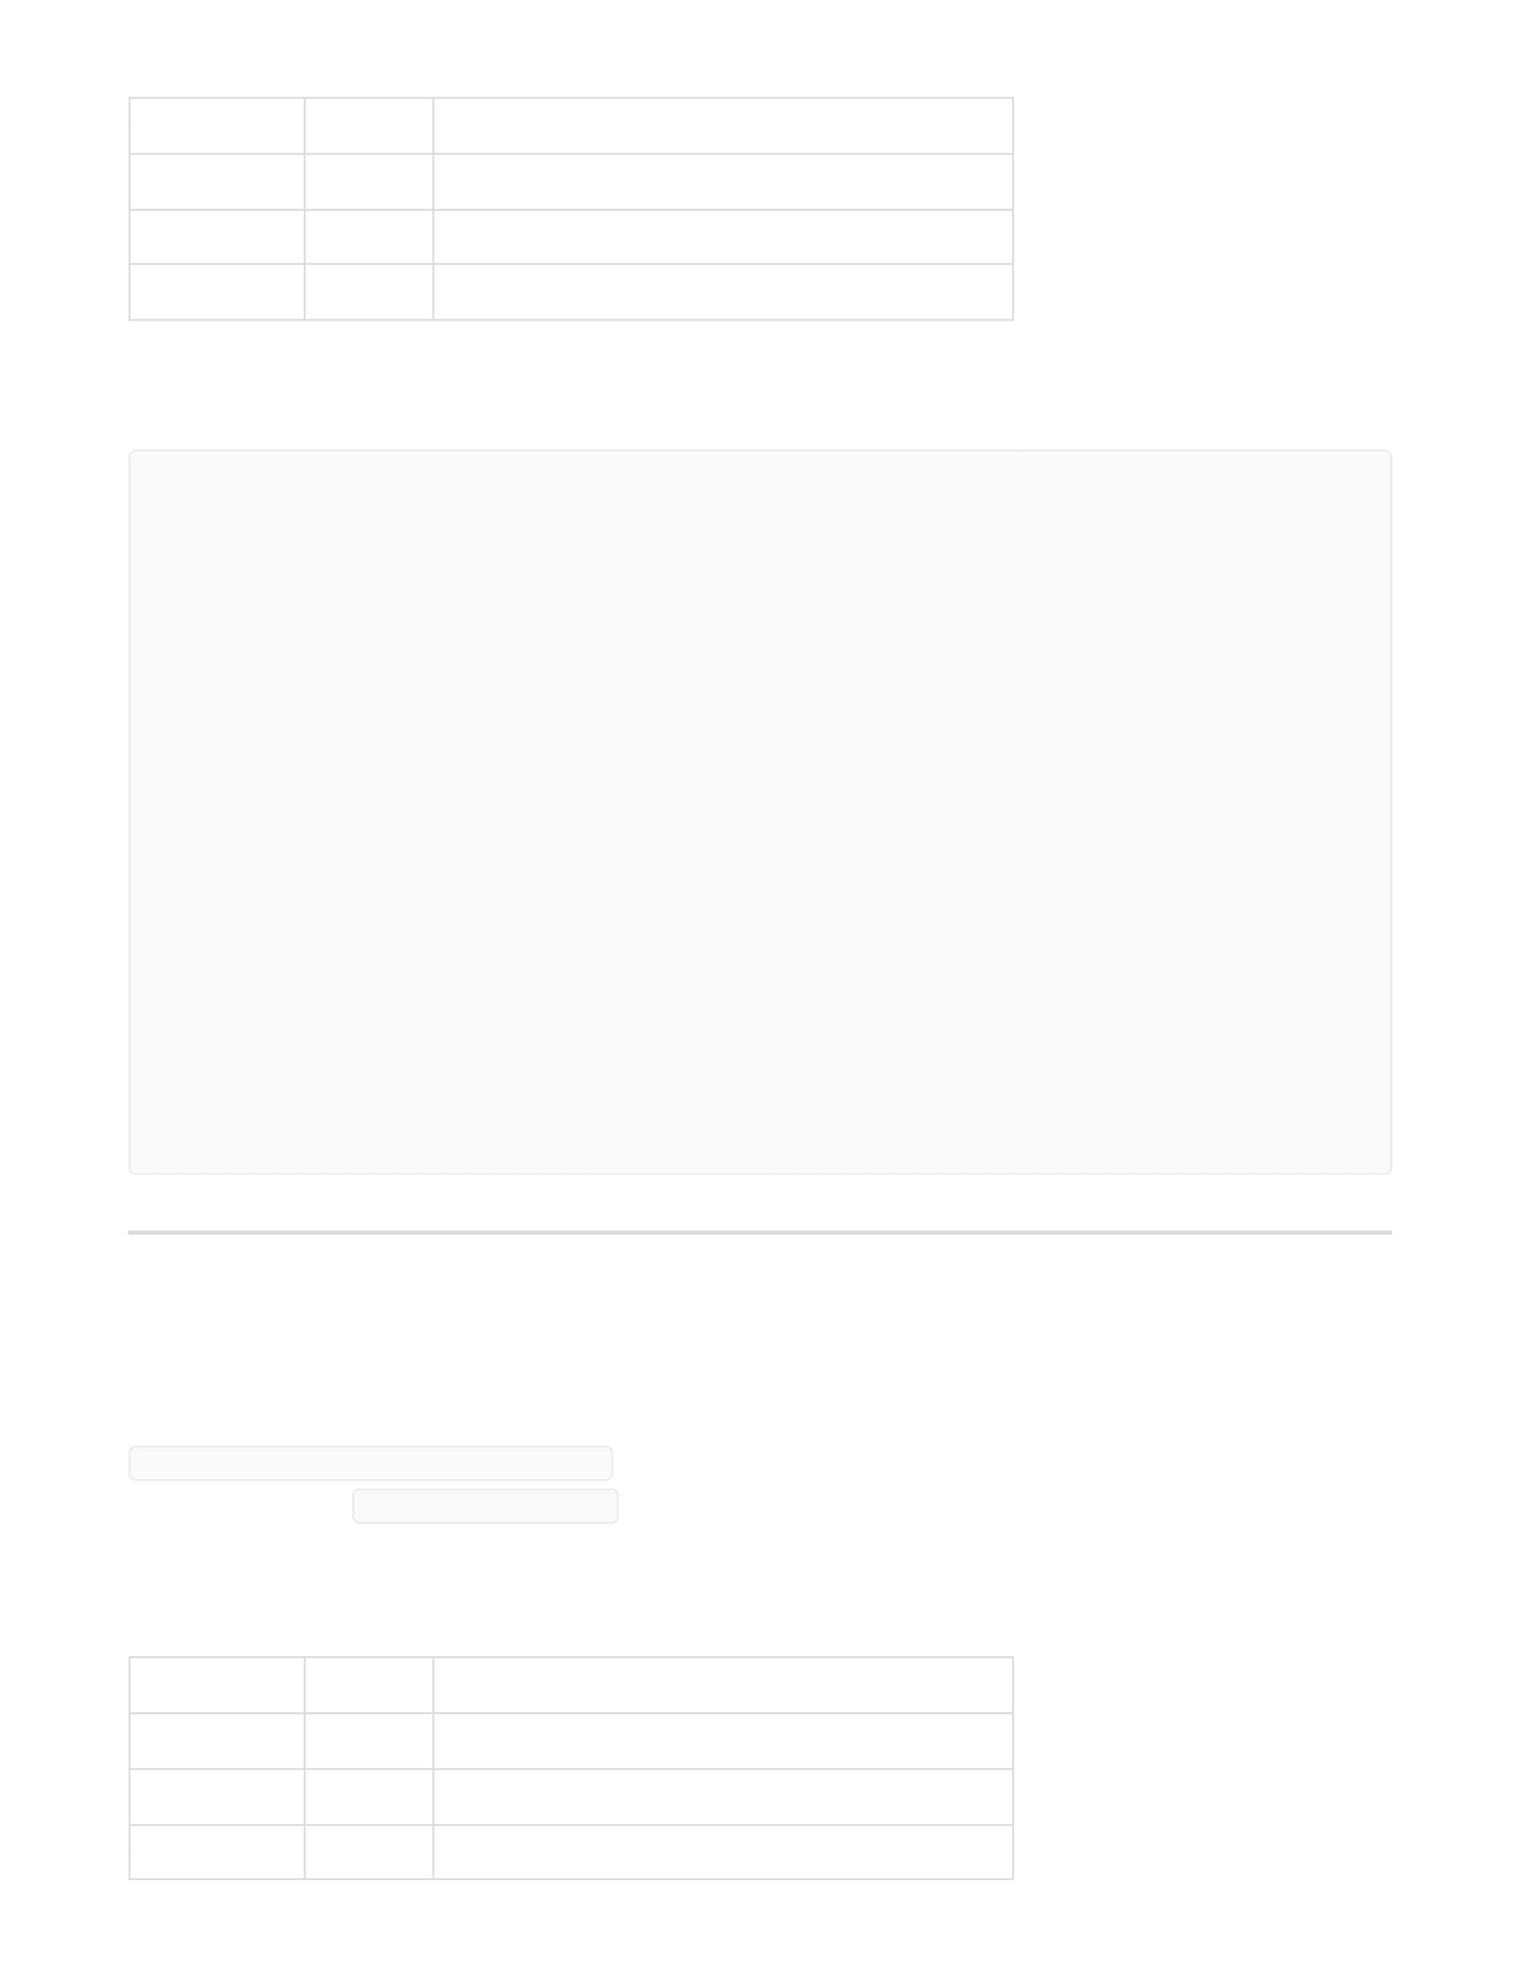
Parameter
Type
Description
theatre_id
integer
Filter by theatre (THEATRE_OWNER only)
year
integer
Filter by year
month
integer
Filter by month
Parameter
Type
Description
theatre_id
integer
Filter by theatre (THEATRE_OWNER only)
year
integer
Filter by year
month
integer
Filter by month
Response :
Peak Show Times
text
GET /analytics/peak-show-times
Authorization : Bearer < token >
Query Parameters:
[
{
"movie_id": 1,
"movie_name": "Thaai Kizhavi",
"no_of_shows": 5,
"seats_booked": 4,
"seats_not_booked": 90
},
{
"movie_id": 2,
"movie_name": "Vadam",
"no_of_shows": 32,
"seats_booked": 4,
"seats_not_booked": 1556
}
]

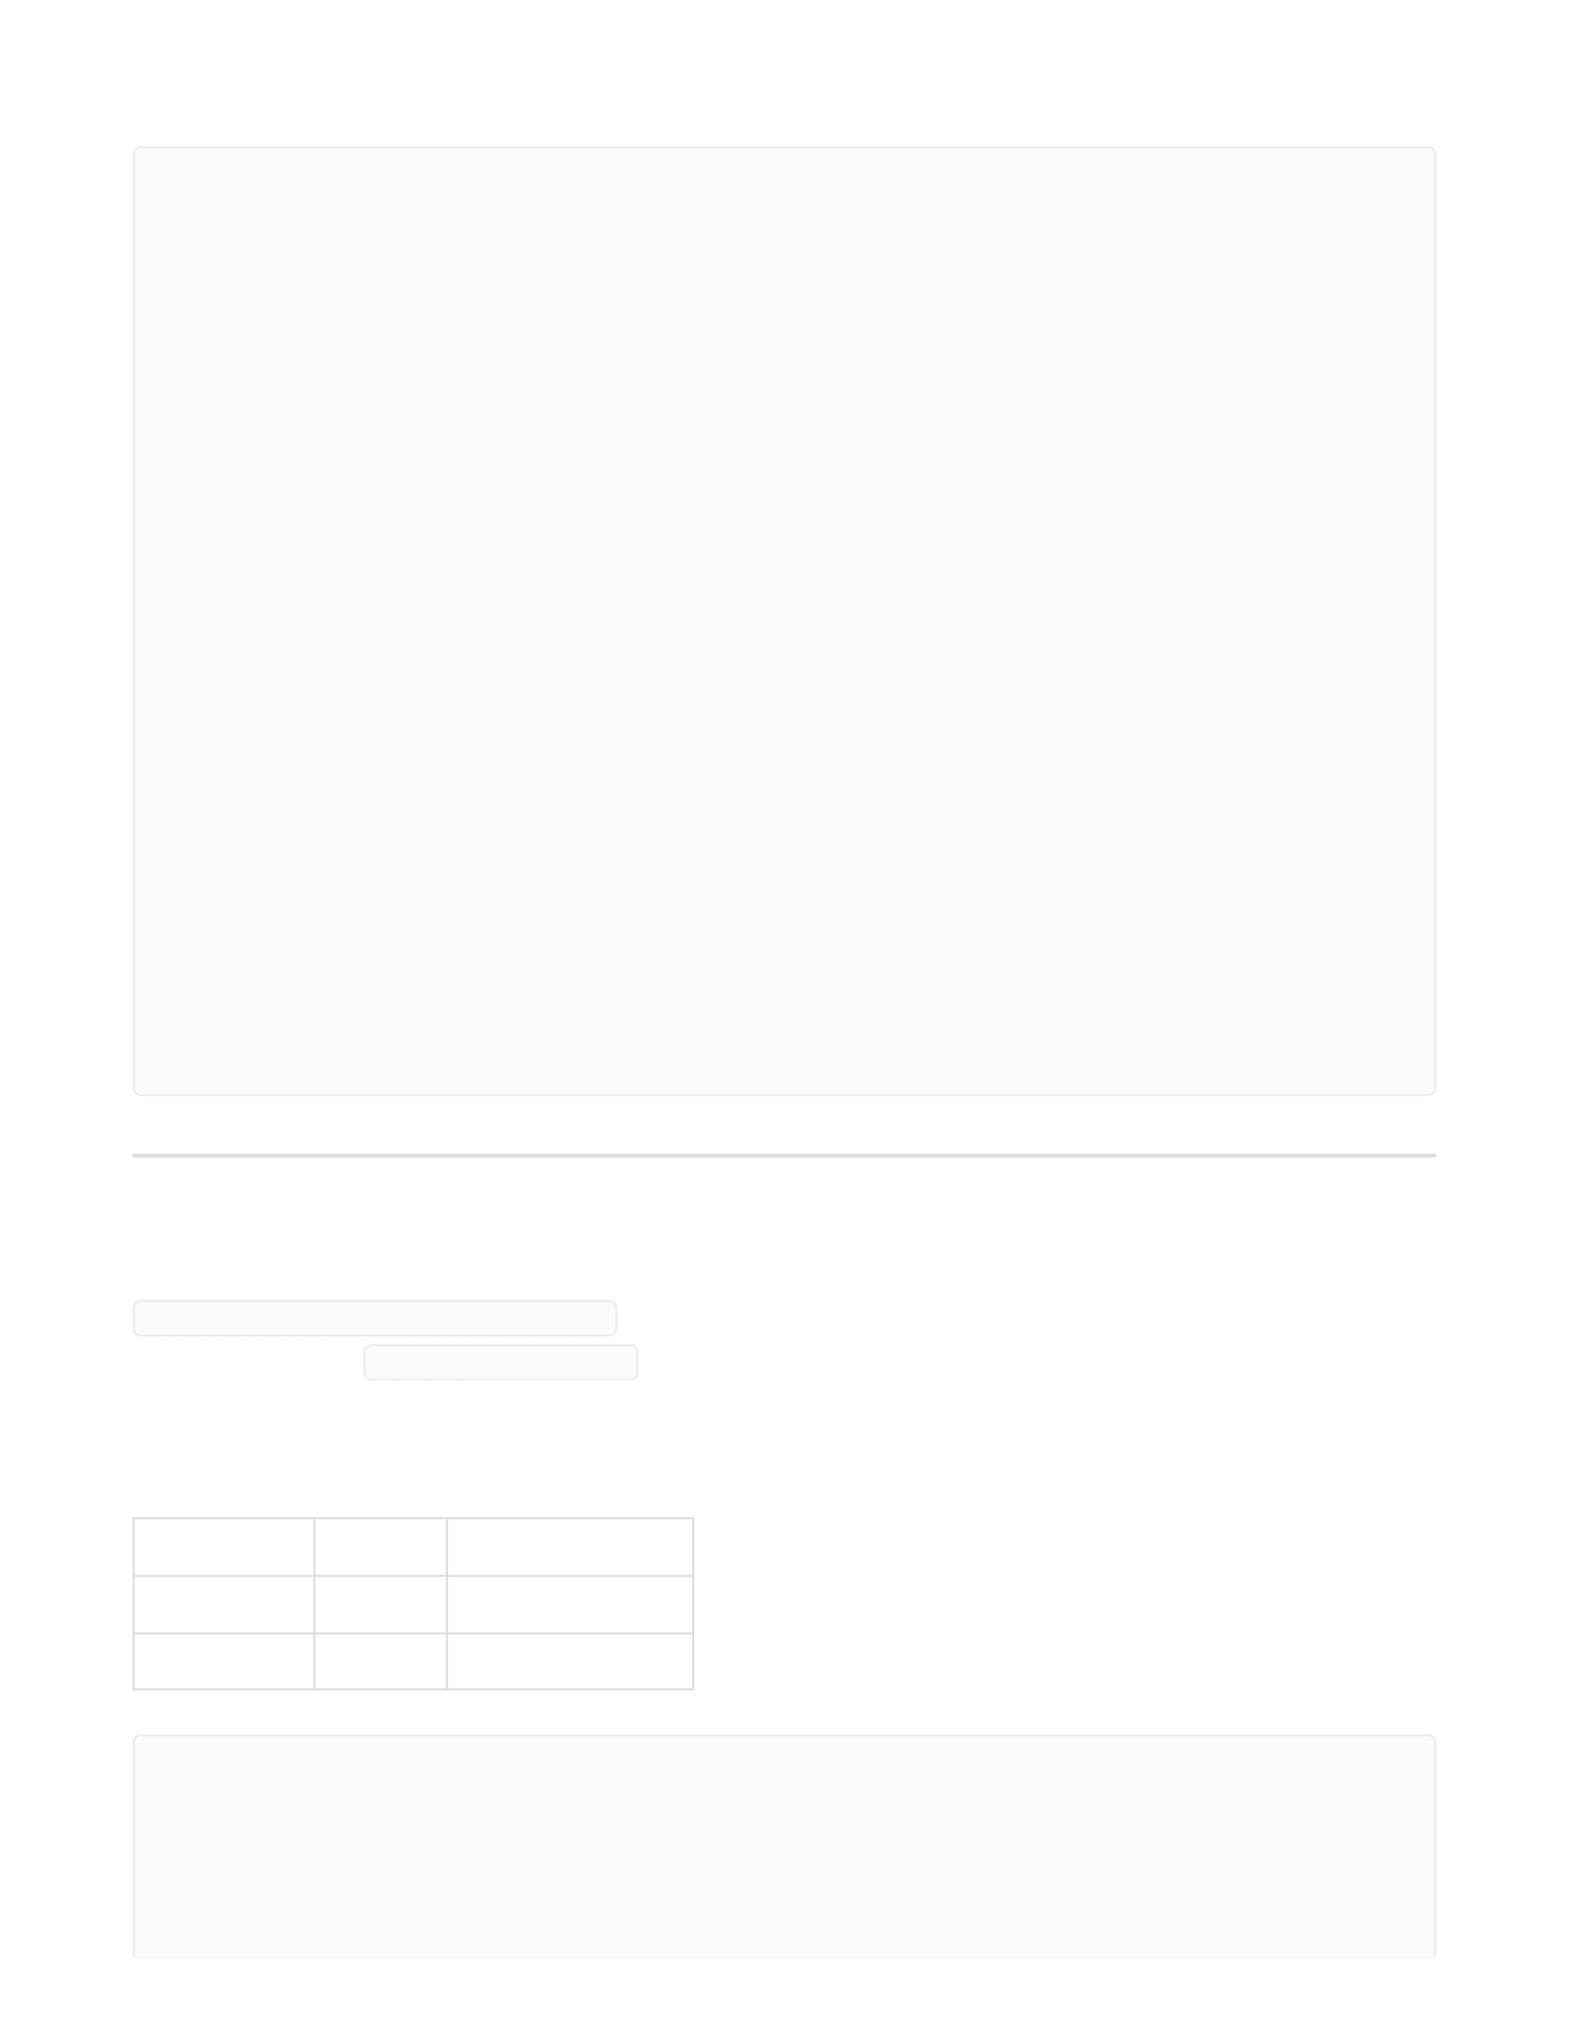
Parameter
Type
Description
year
integer
Filter by year
month
integer
Filter by month
**Response:
User Bookings Analytics
GET /analytics/users-bookings
Authorization : Bearer < token >
Query Parameters:
[
{
"show_category": "Evening",
"seats_booked": 4,
"seats_not_booked": 34
},
{
"show_category": "Morning",
"seats_booked": 0,
"seats_not_booked": 16
},
{
"show_category": "Night",
"seats_booked": 0,
"seats_not_booked": 20
},
{
"show_category": "Late Night",
"seats_booked": 0,
"seats_not_booked": 20
}
]
[
{
"user_id": 1,
"first_name": "Ram",

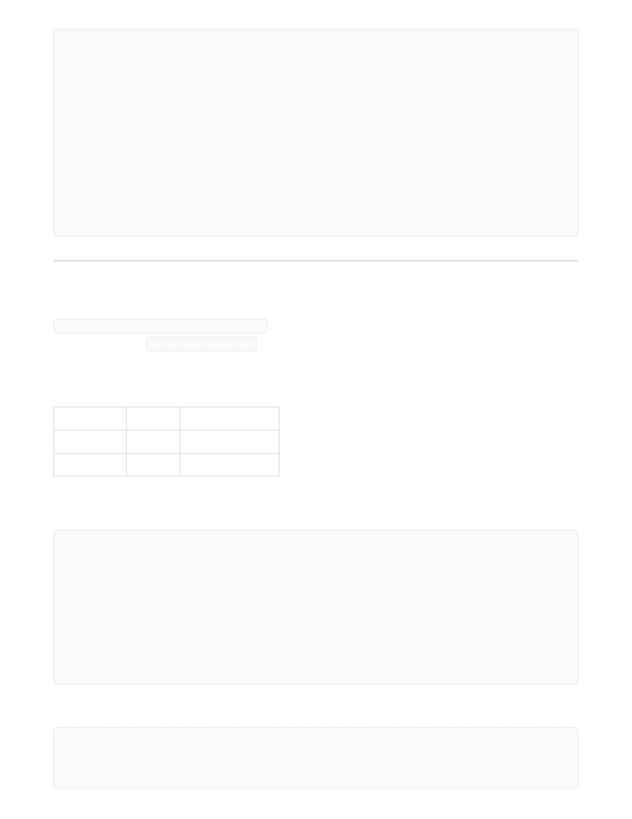
Parameter
Type
Description
year
integer
Filter by year
month
integer
Filter by month
Theatre Bookings Analytics
GET /analytics/theatres-bookings
Authorization : Bearer < token >
Query Parameters:
Response for theatre Owner:
Response for Admin:
"no_of_bookings": 2,
"no_of_seats": 4
},
{
"user_id": 10,
"first_name": "Naveen",
"no_of_bookings": 2,
"no_of_seats": 4
}
]
[
{
"theatre_id": 4,
"theatre_name": "Rohini Cinemas",
"no_of_bookings": 0,
"no_of_seats_booked": 0
}
]
[
{
"theatre_id": 1,

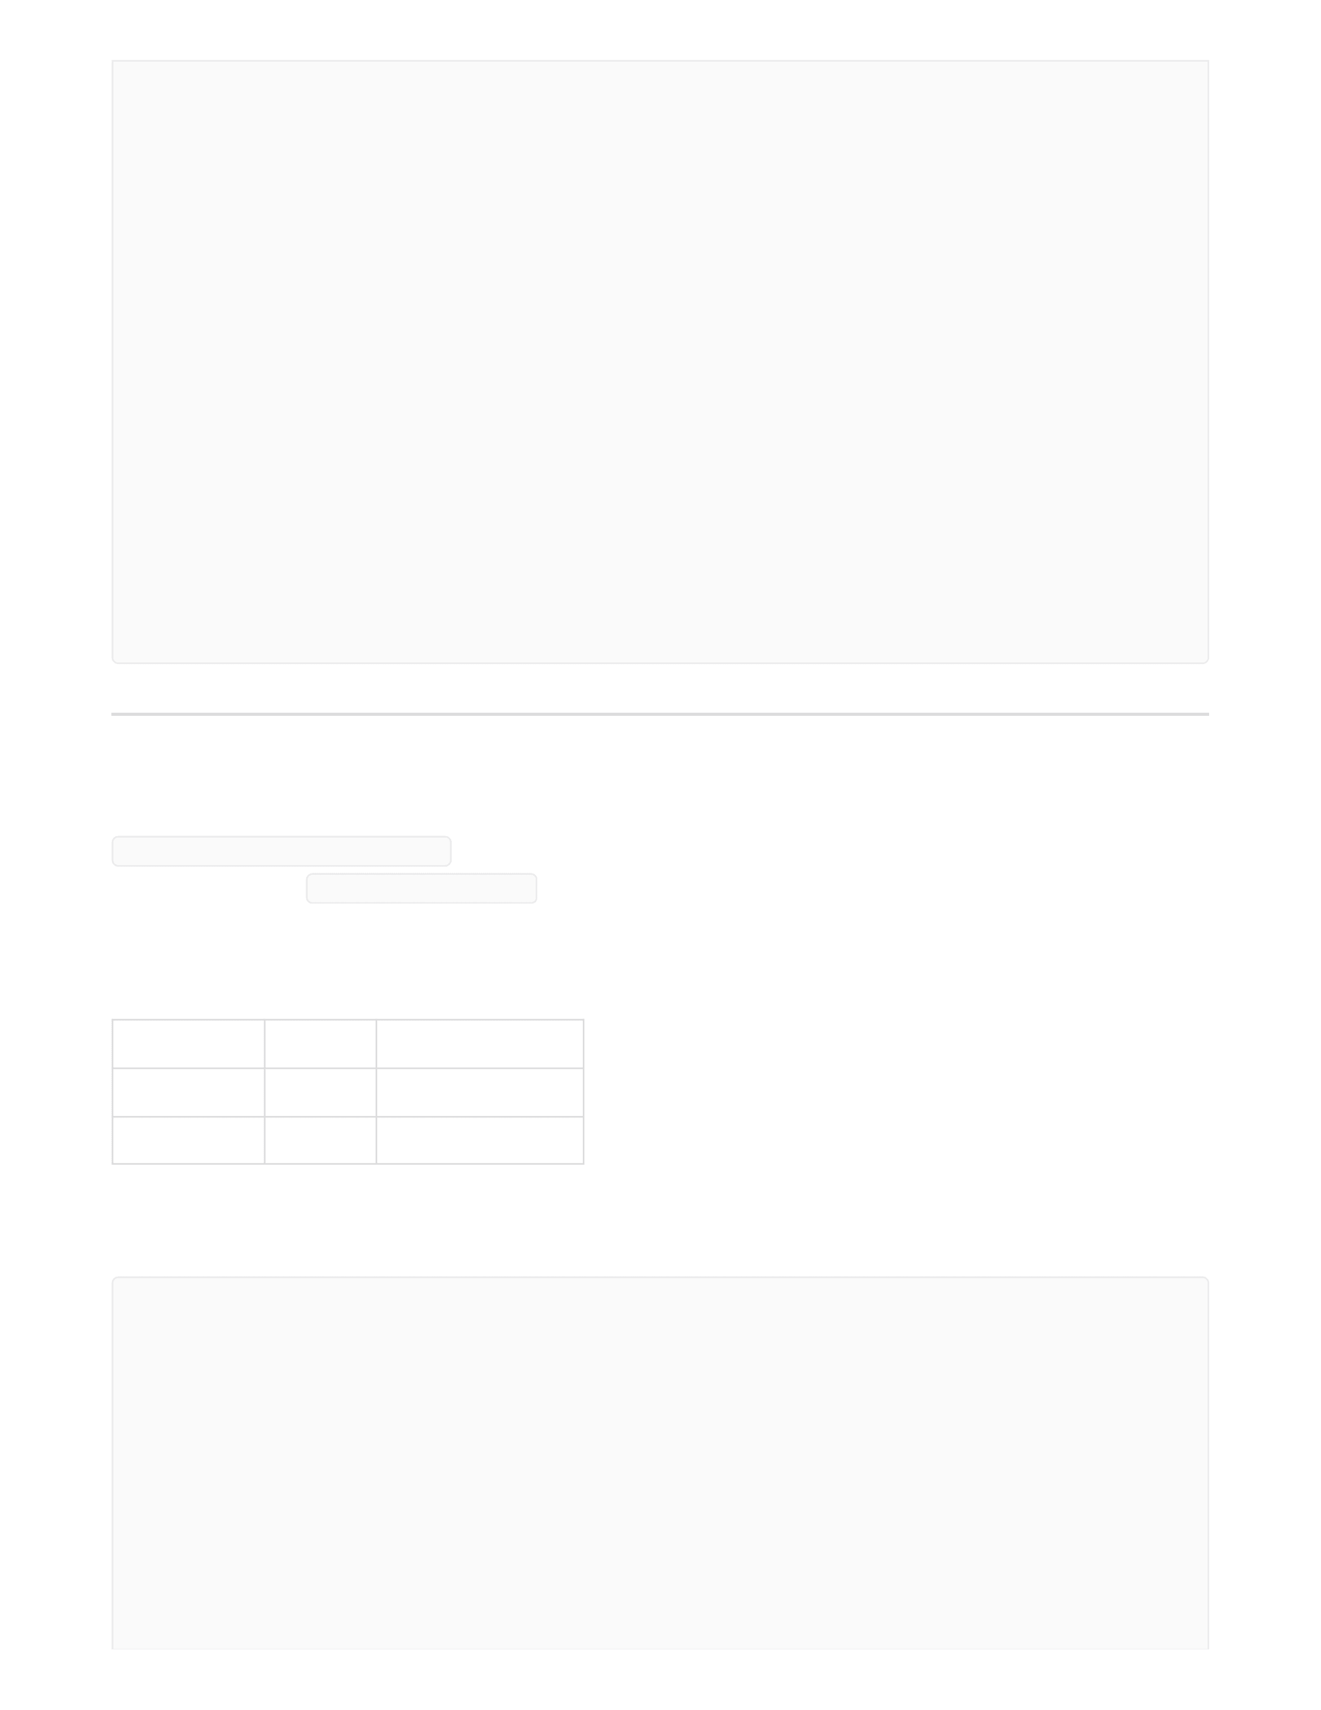
Parameter
Type
Description
year
integer
Filter by year
month
integer
Filter by month
Top Spent Users
GET /analytics/top-spent
Authorization : Bearer < token >
Query Parameters:
Response :
"theatre_name": "SVR Visuals",
"no_of_bookings": 2,
"no_of_seats_booked": 4
},
{
"theatre_id": 2,
"theatre_name": "Vetri Cinemas..",
"no_of_bookings": 2,
"no_of_seats_booked": 4
},
{
"theatre_id": 3,
"theatre_name": "PVR Cinemas",
"no_of_bookings": 0,
"no_of_seats_booked": 0
}
]
[
{
"user_id": 1,
"first_name": "Ram",
"amount_spent": 894.0
},
{
"user_id": 10,
"first_name": "Naveen",
"amount_spent": 768.0

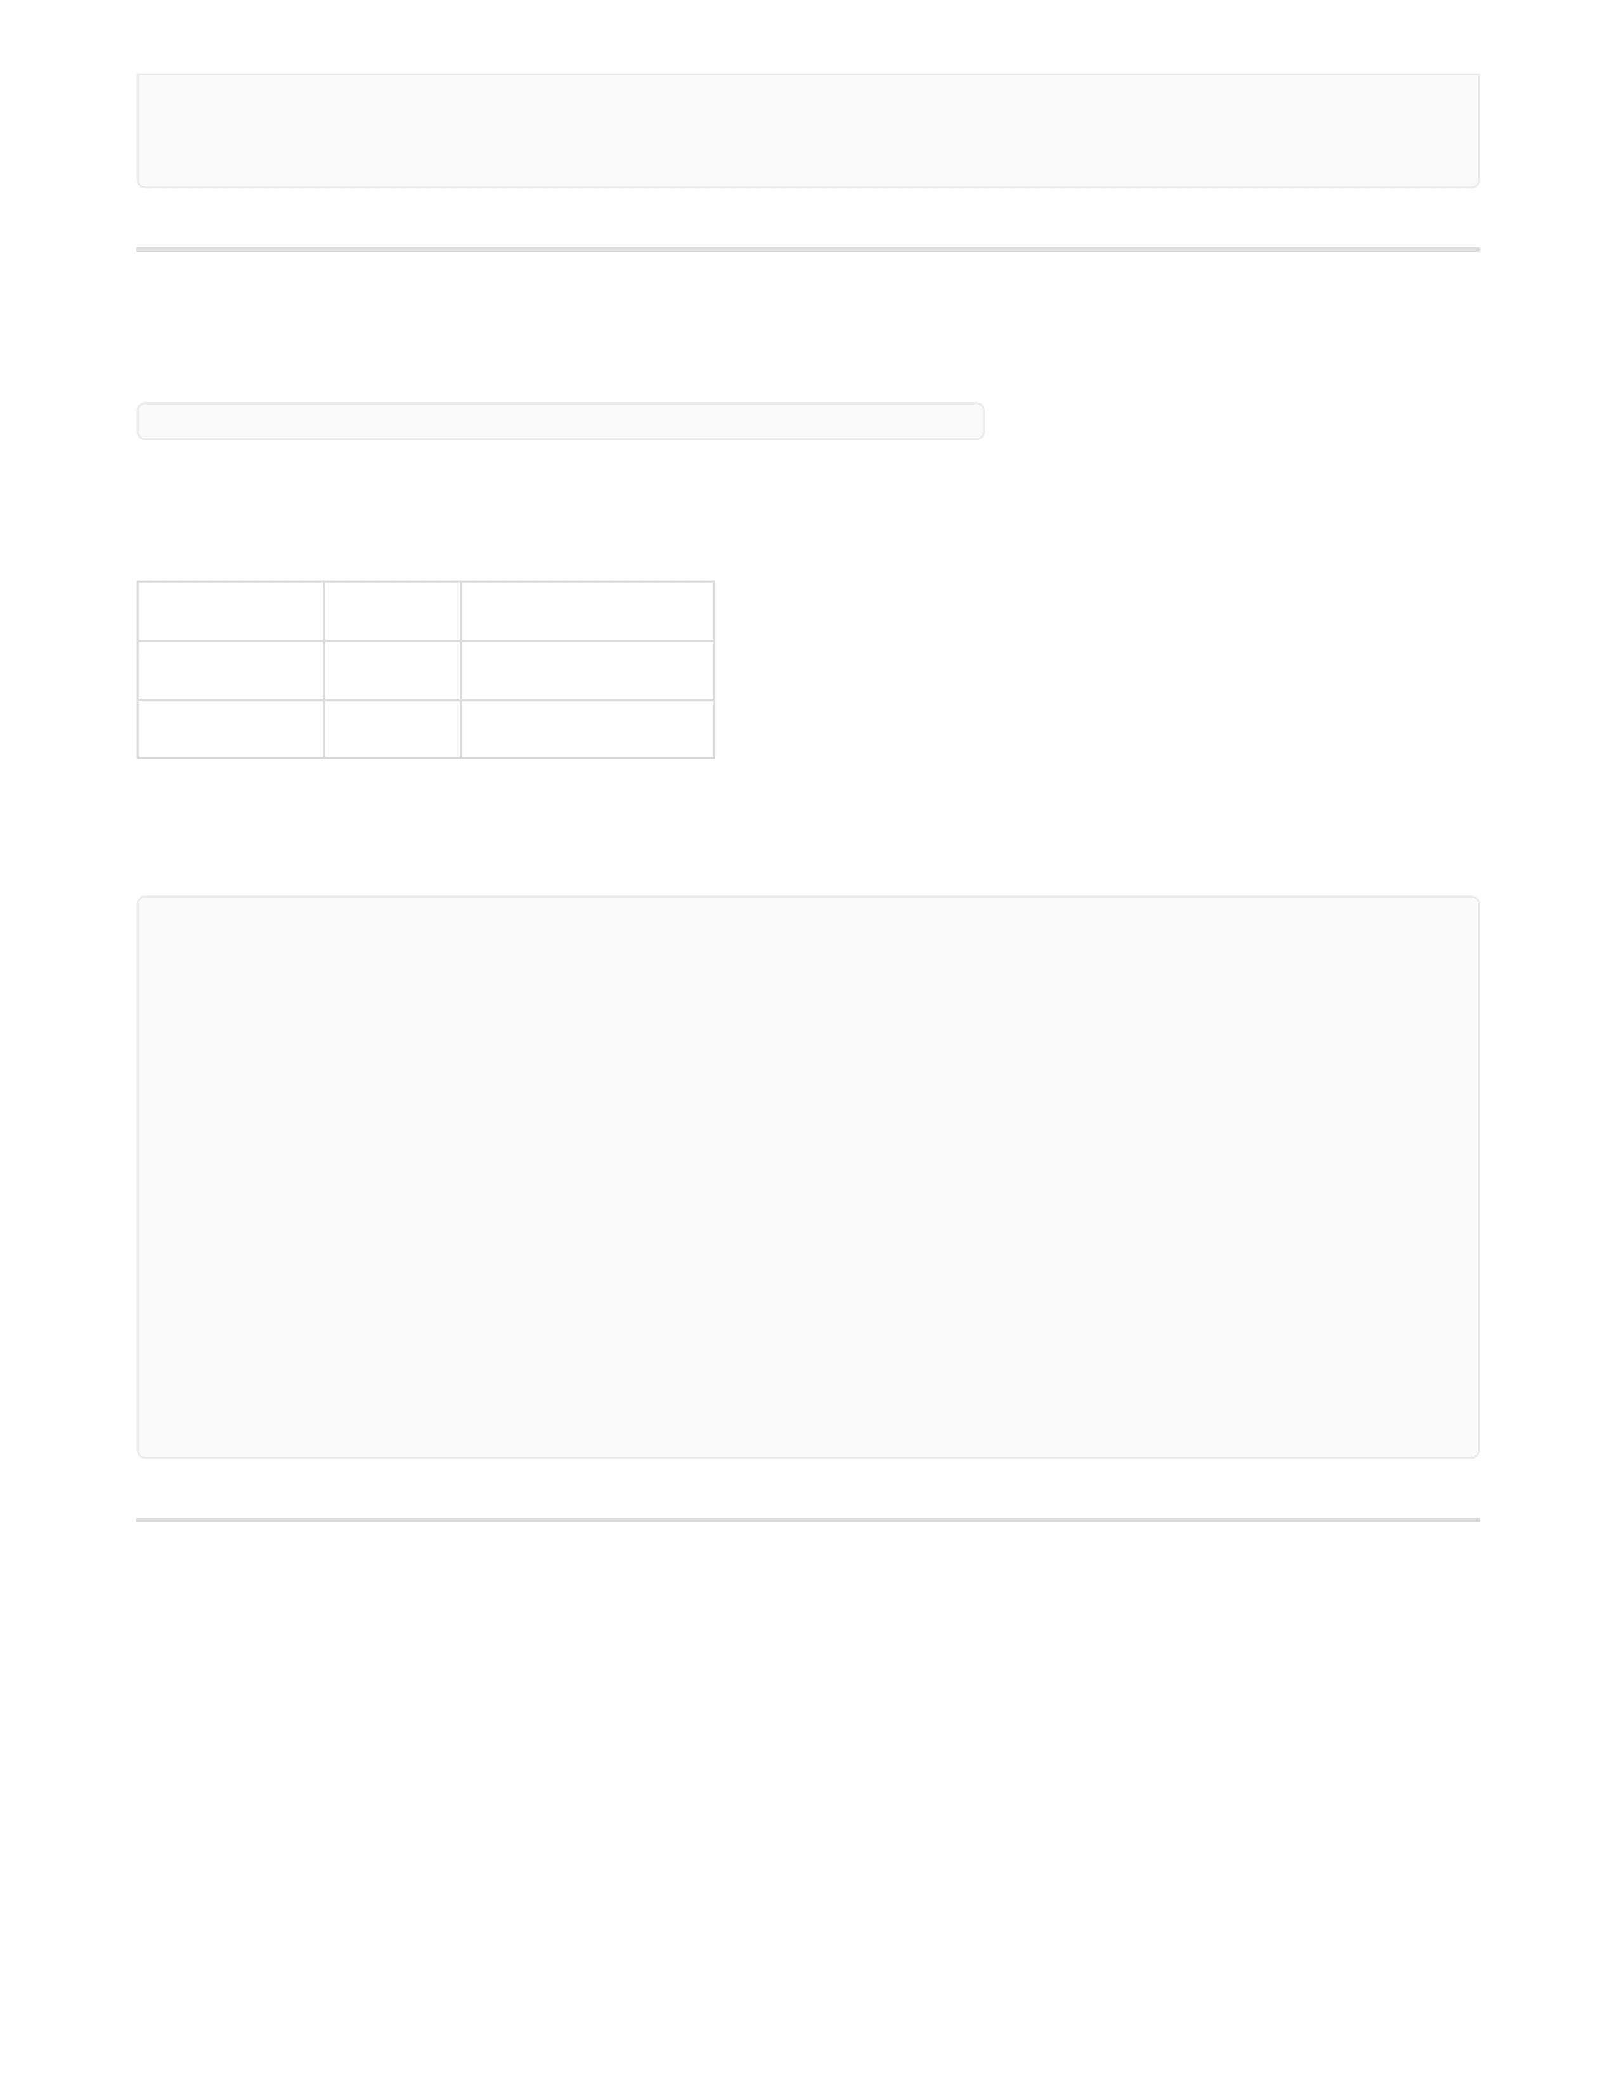
Parameter
Type
Description
year
integer
Filter by year
month
integer
Filter by month
Theatre Revenue
GET analytics/theatres-revenue ***Authorization : Bearer < token >`***
Query Parameters:
Response :
}
]
[
{
"theatre_id": 1,
"theatre_name": "SVR Visuals",
"revenue": 894.0
},
{
"theatre_id": 2,
"theatre_name": "Vetri Cinemas..",
"revenue": 768.0
}
]

